KB ENGINEERING COATINGS SDN. BHD.

(Co. No: 831283D)

No. 22 Jalan TS 6/9, Taman Industri Subang, 47510 Subang Jaya,

Selangor Darul Ehsan. Tel: 03 - 58798762 Fax: 03-56215266

GST Reg. No. 001438527488

**Equipment list**

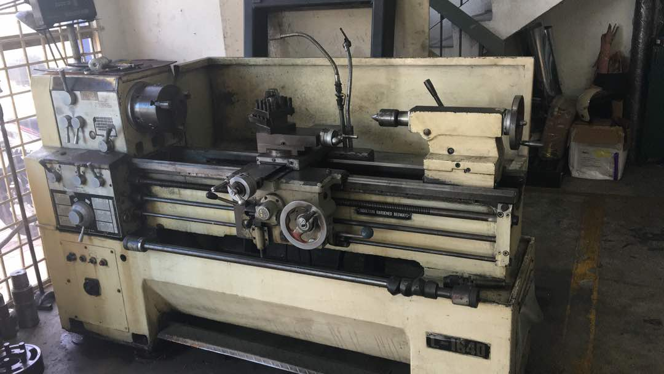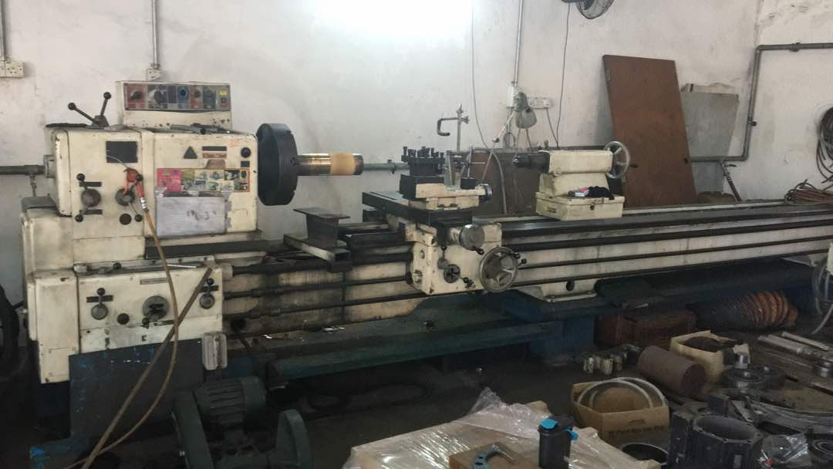

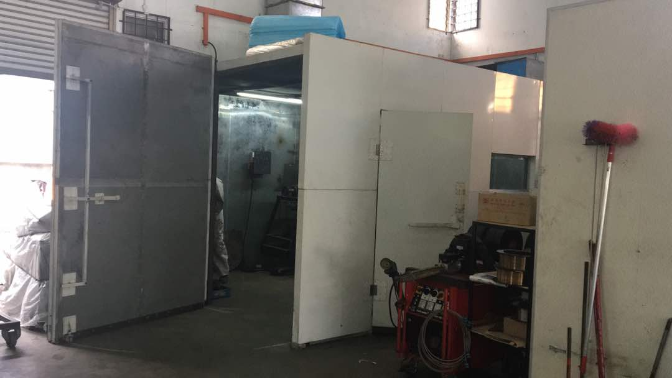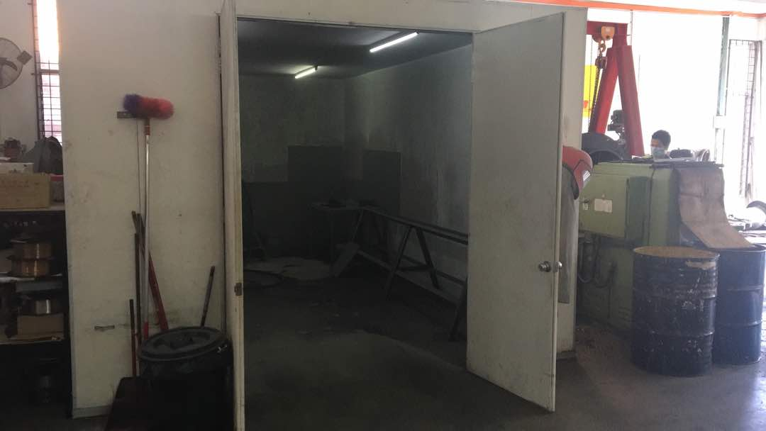1 Meter x Ø300mm Lathe Machine 4 Meter x Ø400mm Lathe machine

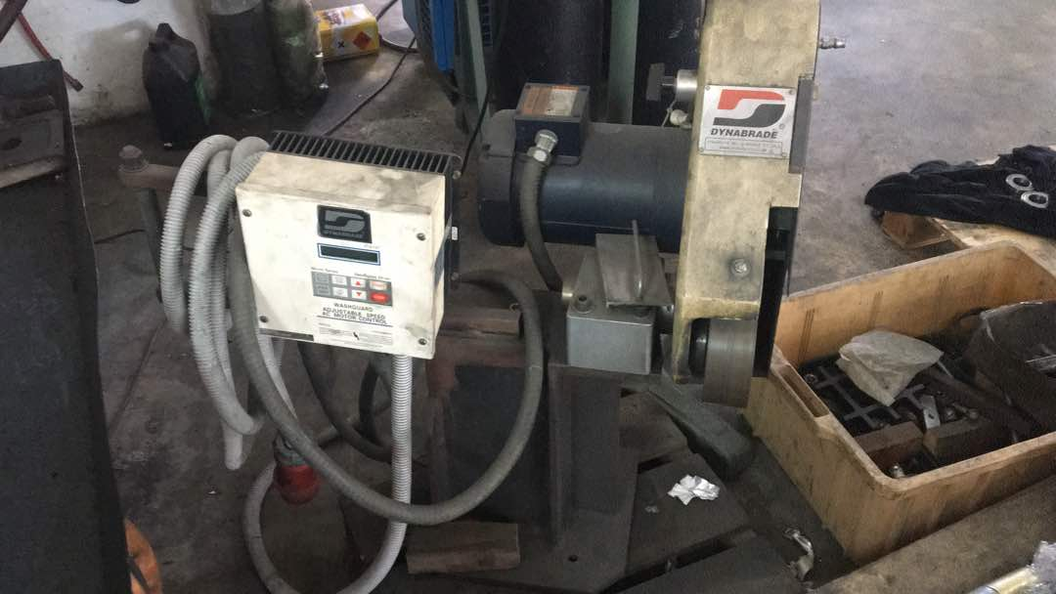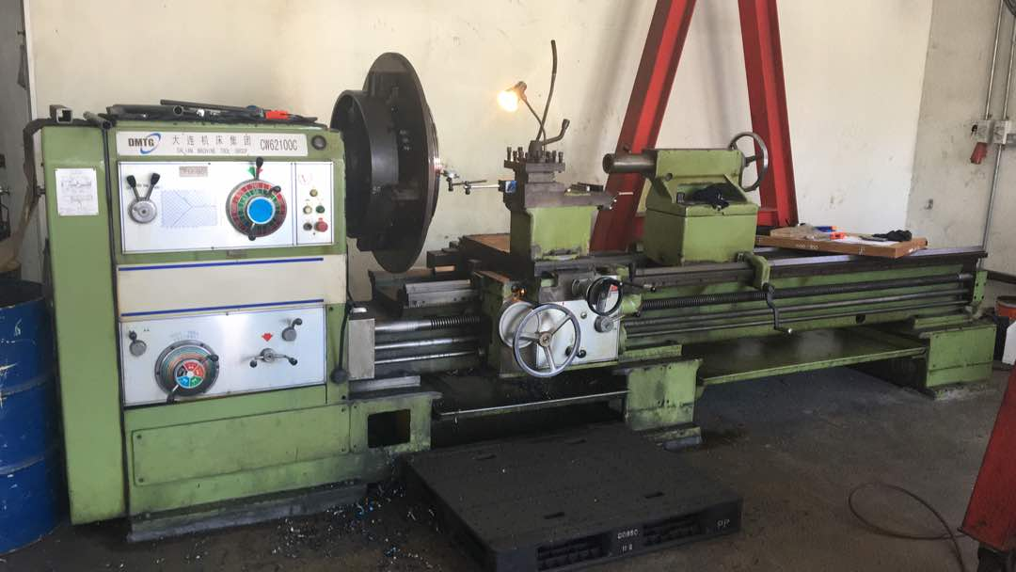

3 Meter x Ø700mm Lathe machine Dynabrade Diamond belt grinder

4m x 3m Grit-Blasting Room Spray room 4M x 3m.

KB ENGINEERING COATINGS SDN. BHD.

(Co. No: 831283D)

No. 22 Jalan TS 6/9, Taman Industri Subang, 47510 Subang Jaya,

Selangor Darul Ehsan. Tel: 03 - 58798762 Fax: 03-56215266

GST Reg. No. 001438527488

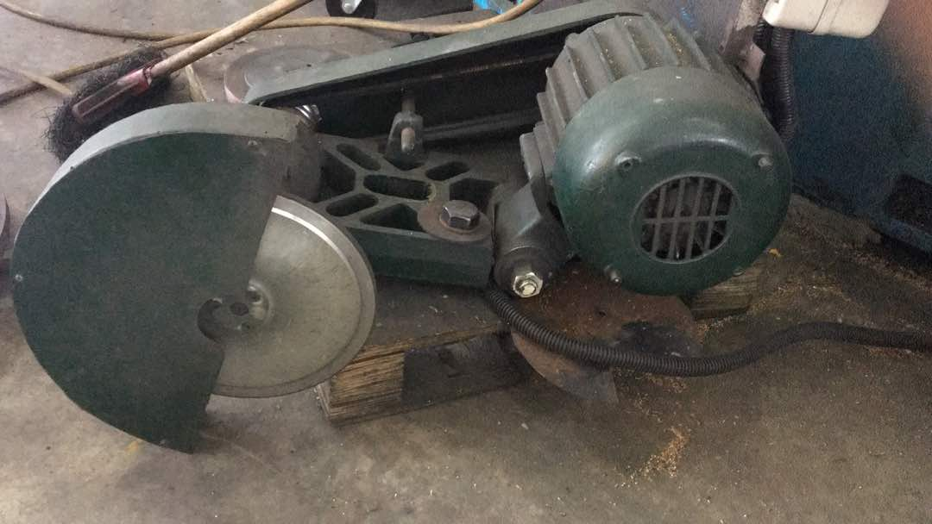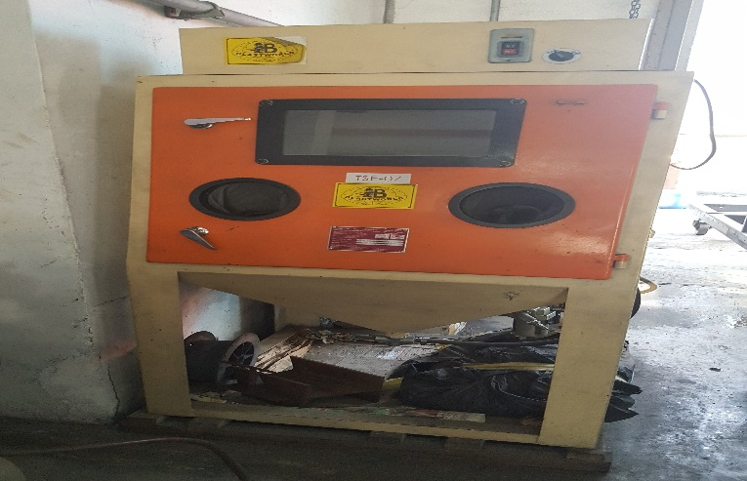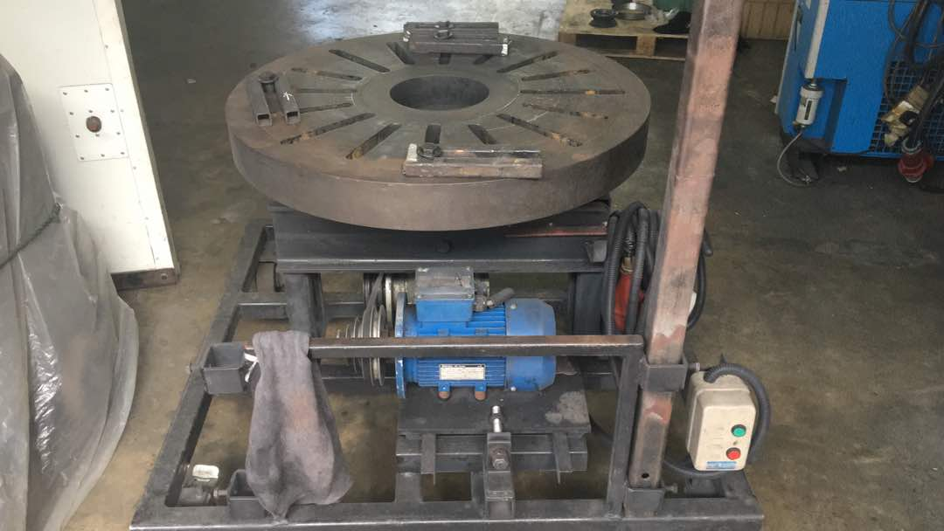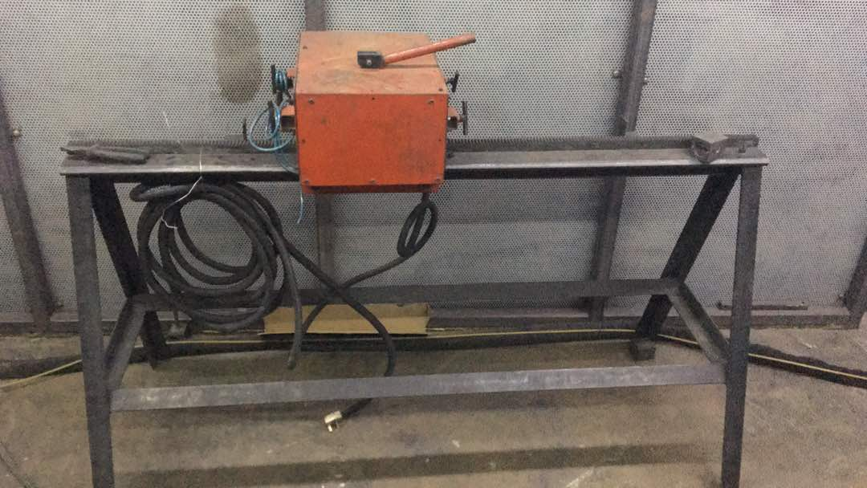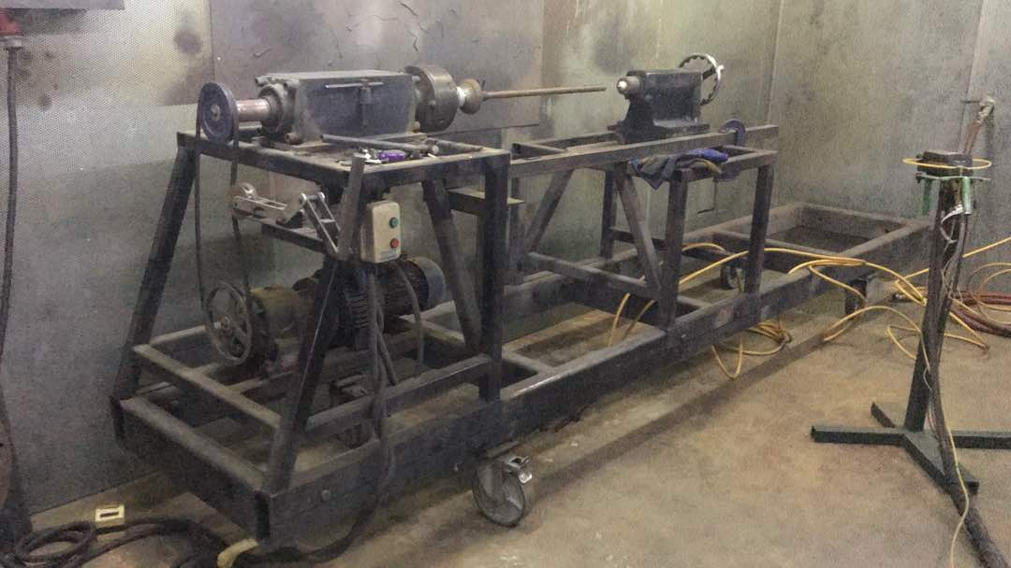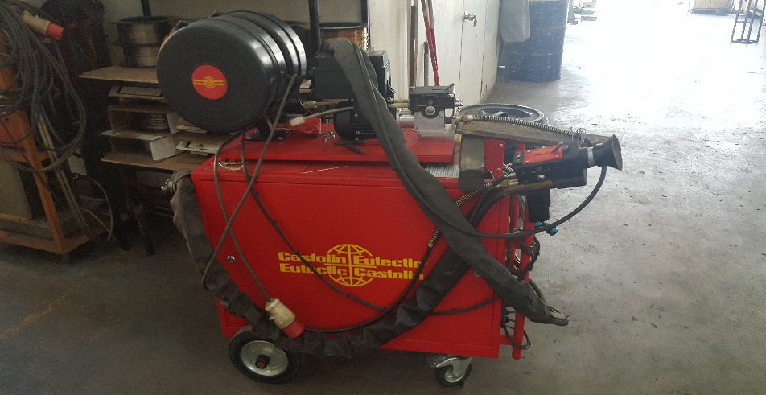

Horizontal Rotator

Traverse Unit

Sand Blasting Cabinet

Tool post Diamond wheel

Rotator

Eutectic Castolin Arc-Spray system

KB ENGINEERING COATINGS SDN. BHD.

(Co. No: 831283D)

No. 22 Jalan TS 6/9, Taman Industri Subang, 47510 Subang Jaya,

Selangor Darul Ehsan. Tel: 03 - 58798762 Fax: 03-56215266

GST Reg. No. 001438527488

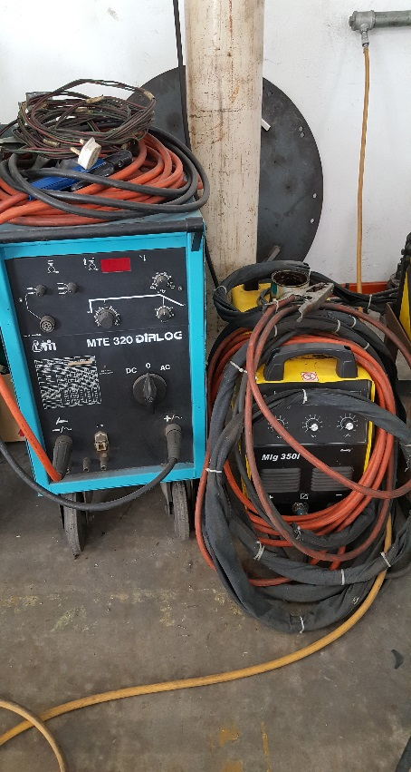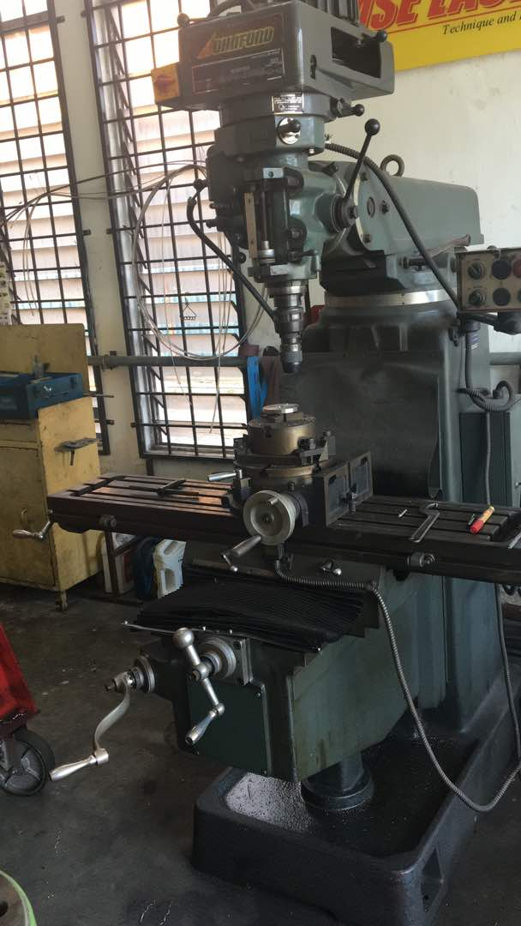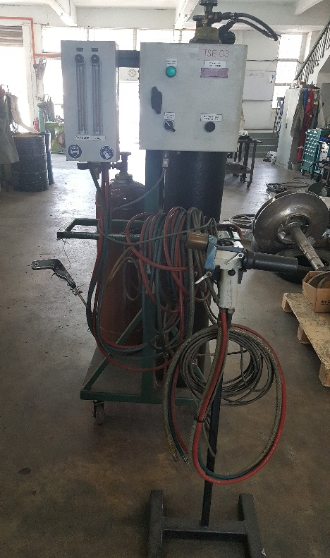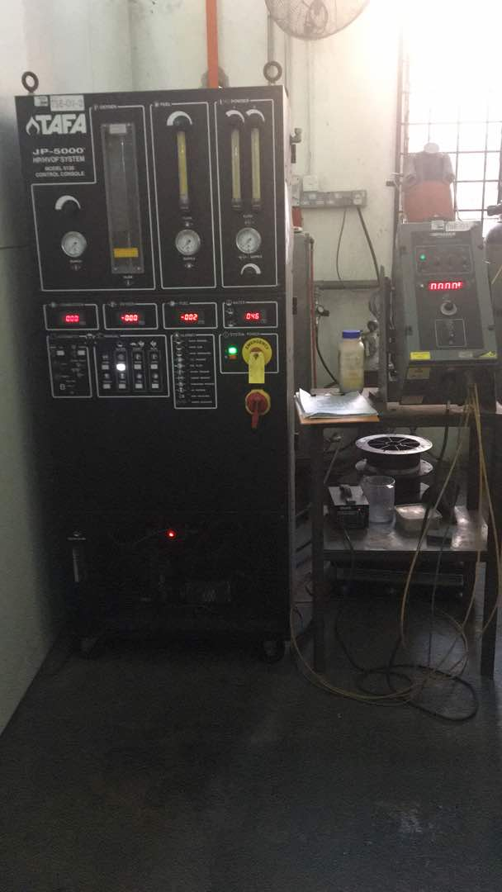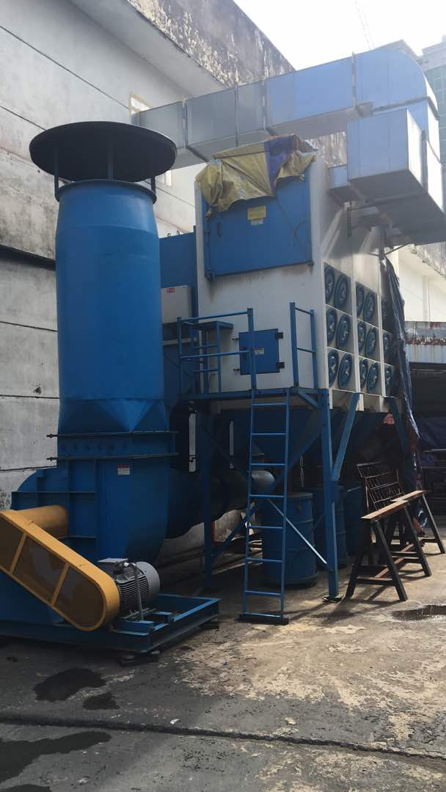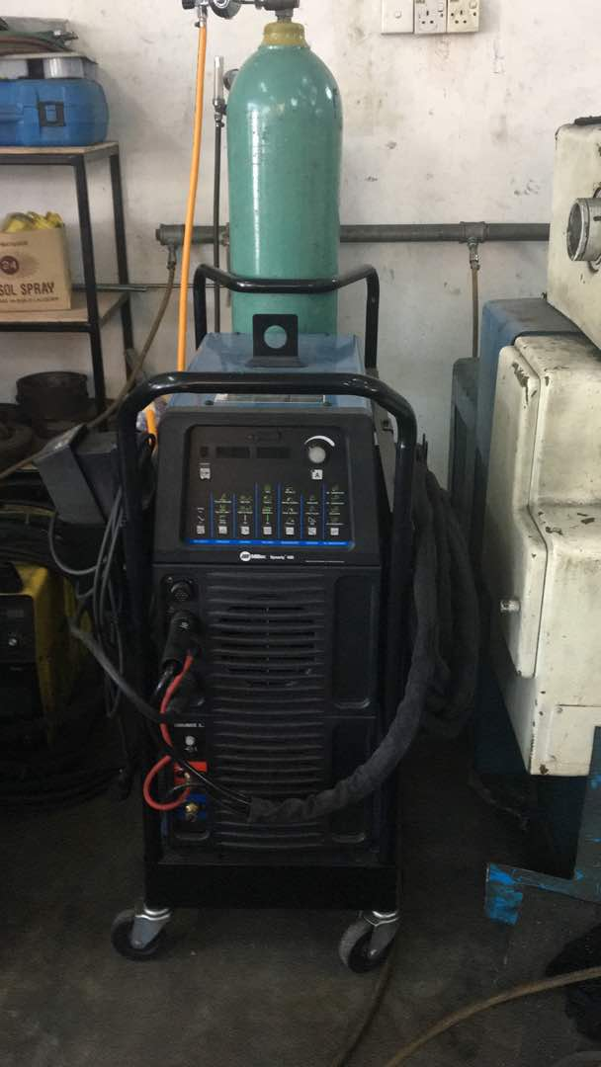

Welding unit

Milling Machine

Miller TIG Machine

Master Jet (For ceramic application)

HVOF TAFA JP5000

Dust extractor